Unit 4
DATA CONVERTER AND CONNTECTORS
- Analog to Digital Converter (ADC) and Digital to Analog Converter (DAC): Principle and Specification
An Analog-to-Digital Converter (ADC) and a Digital-to-Analog Converter (DAC) are essential components in digital signal processing systems, enabling the conversion between analog and digital signals.
Analog-to-Digital Converter (ADC):
A converter that is used to change the analog signal to digital is known as an analog to digital converter or ADC converter. This converter is one kind of integrated circuit or IC that converts the signal directly from continuous form to discrete form. This converter can be expressed in A/D, ADC, A to D.
Principle: An ADC converts continuous analog signals into discrete digital representations. This process involves sampling the analog signal at regular intervals, quantizing each sample into a digital value, and encoding it in binary format.
The basic function of an ADC is shown below.
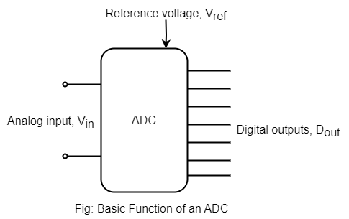
The digital output, D_{out} is the n-bit digital output world while V_{in} and V_{ref} are the analog input and reference signals respectively.
For an ADC, these signals are related by;
$$V_{ref}\left(D_{0}2^{-2n}+D_{1}2^{-\left(n-1\right)}+D_{2}2^{-\left(n-2\right)}+…………..+D_{n-1}2^{-1}\right)=V_{in}±V_{x}$$
Where, D₀ is LSB and D_{n-1} is MSB and V_{x} is given by;
$$\left(-\frac{1}{2}\right)V_{LSB}≤V_{x}\left(\frac{1}{2}\right)V_{LSB}$$
The analog to digital conversion process is known as quantization.
Specification:
- Resolution: Resolution refers to the number of bits used to represent the analog signal digitally.
- Sampling Rate: Sampling determines how often the ADC samples the analog signal per second, higher sampling rates allow capturing higher-frequency components of the analog signal.
- Input Range: Input range specifies the range of analog voltages that the ADC can accurately convert to digital values.
- Accuracy: Accuracy refers to the deviation of the ADC's output from the ideal digital representation of the input signal.
- Conversion Time: Conversion time is the time taken by the ADC to convert an analog sample into a digital value.
Digital to Analog Converter (DAC):
A Digital to Analog Converter (DAC) converts a digital input signal into an analog output signal. The digital signal is represented with a binary code, which is a combination of bits 0 and 1.
Principle: A DAC converts digital representations of signals into analog voltages or currents. This process involves decoding digital values into corresponding analog output voltages or currents, typically using resistive networks, current sources, or pulse-width modulation (PWM) techniques.
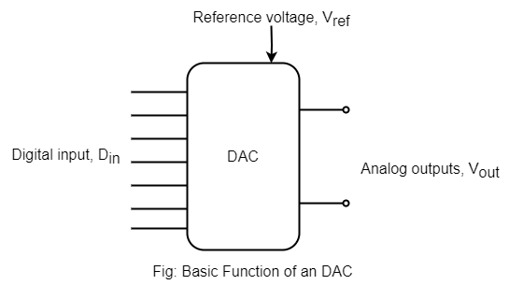
Digital input D_{in} is defined as an n-bit digital word such that
$$D_{in}=D_{0}2^{-2}+D_{1}2^{-\left(n-1\right)}+D_{1}2^{-\left(n-2\right)}+ …………+D_{n-1}2^{-1}$$
Where,
D₀ is LSB and D_{n-1} is MSB. The analog output signal V_{out} is related to the digital input signal, D_{in} through an analog voltage reference, V_{ref}. The relation;
$$V_{out}=V_{ref}\left(D_{0}2^{-n}+D_{1}2^{-\left(n-1\right)}+D_{2}2^{-\left(n-2\right)}+ …………..+D_{n-1}2^{-1}\right)$$
$$V_{out}=V_{ref}×D_{in}$$
V_{LSB} may be defined as to be the voltage change when one LSB changes or mathematically,
$$V_{LSB}=\frac{V_{ref}}{2^{n}}$$

Specification:
- Resolution: Resolution refers to the number of bits used to represent the digital input and determine the DAC's output granularity. Higher resolution DACs provide finer resolution and accuracy in generating analog signals.
- Output Range: Output range specifies the range of analog voltages or currents that the DAC can produce.
- Accuracy: Accuracy refers to the deviation of the DAC's output from the ideal analog signal.
- It is often expressed as a percentage of the full-scale range or in terms of least significant bits (LSBs).
- Settling Time: Settling time is the time taken by the DAC's output to settle within a specified error band after a change in the digital input.
- Linearity: Linearity refers to how closely the DAC's output follows the ideal transfer function. Nonlinearity can introduce errors in the output signal, especially at low input voltages.

- Quantization Error
The digitization of analog signals involves the rounding off of the values which are approximately equal to the analog values. The method of sampling chooses a few points on the analog signal and then these points are joined to round off the value to a near stabilized value. Such a process is called as Quantization.
For any system, during its functioning, there is always a difference in the values of its input and output. The processing of the system results in an error, which is the difference of those values. The difference between an input value and its quantized value is called a Quantization Error.
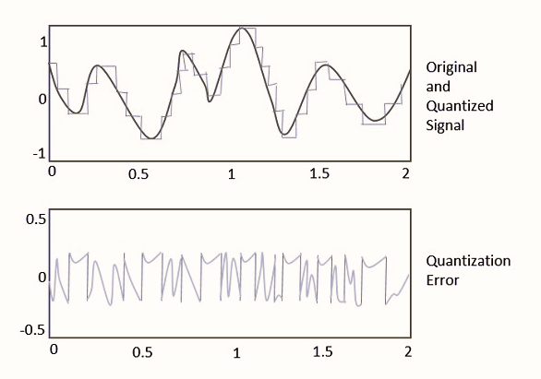
Mitigation of Quantization Error:
- Increasing Resolution: Higher-resolution ADCs provide more quantization levels, reducing the magnitude of quantization error. This leads to finer quantization and improved accuracy in representing the analog signal digitally.
- Dithering: Dithering is a technique used to randomize quantization error by adding a small amount of noise to the input signal. It helps distribute the quantization error more evenly and reduces perceptual artifacts, particularly at low signal levels.
- Noise Shaping: Noise shaping techniques manipulate the quantization error spectrum to push it to higher frequencies where it is less perceptible. This can be achieved using digital signal processing algorithms applied after the ADC.

- Types of ADC
4.3.1 Flash type ADC
The parallel or simultaneous or flash type ADC is the fastest type of ADC. In this type of conversion, parallel comparator compares the reference voltages with analog input voltage. Its main advantage is very high speed of conversion as the speed is restricted only by the switching time of the comparators and the gates.
For a 3-bit converter, there are 2³-1 levels. All the comparators are connected to the reference voltage less than the input voltage. The comparator output is decoded to give 3-bits combination analog at output of encoder. It performs faster analog to digital conversion.
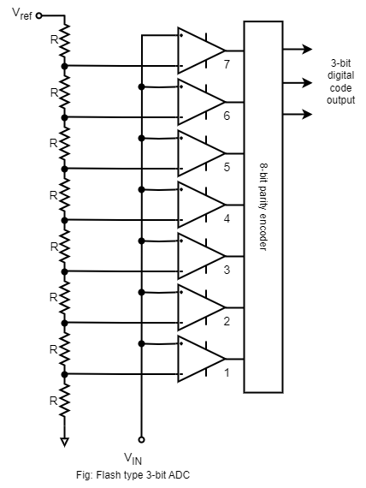
The flash ADC uses no clock signal because there in not timing or sequencing period. The conversion takes place simultaneously. The only delays in the conversion are in the comparators and priority encoders. The voltage applied to the inverting terminal of the upper most comparator is $\frac{7R}{7R+R}×V_{ref}=\frac{7}{8}V_{ref}$ by voltage divider rule.
Similarly, the voltage applied to the inverting terminal of next comparator is
$\frac{6R}{7R+R}×V_{ref}=\frac{6}{8}V_{ref}$ and so forth. The increment between voltage is $\frac{1}{8}V_{ref}$.
Advantages:
- The fastest conversion process
- Highest accuracy
- Highest resolution possible by increasing the number of comparators.
Disadvantages:
- Complex circuit
- Costly

4.3.2 Counter type ADC
The counter type ADC is constructed using a binary counter, DAC and a comparator. The output voltage of a DAC is VD which is equivalent to corresponding digital input to DAC.
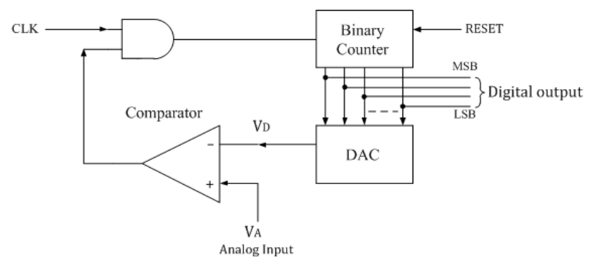
The n-bit binary counter is initially set to 0 by using reset command. Therefore the digital output is zero and the equivalent voltage V_{D} is also 0V. When the reset command is removed, the clock pulses are allowed to go through AND gate and are counted by the binary counter. The digital to analog converter (DAC) converts the digital output to an analog voltage and applied as the inverting input to the comparator. The output of the comparator enables the AND gate to pass the clock.
The counting stops at the instance V_{A}< V_{D}, and at that instant the counter stops its progress and the conversion is said to be complete.
Advantages:
- Simple construction.
- Easy to design and less expensive.
- Speed can be adjusted by adjusting the clock frequency.
- Faster than dual slope type ADC.
Disadvantages:
- Speed is less, since each time the counter has to begin from ZERO.
- There may be conflicts if the next input is sampled before completion of one process.

4.3.3 Successive Approximation type ADC
This is one of the most widely used methods of (A/D) conversion. A clock is used to emit the regular sequence of pulse i.e. 0s and 1s which are stored in 4-bit storage register and become the input of DAC.
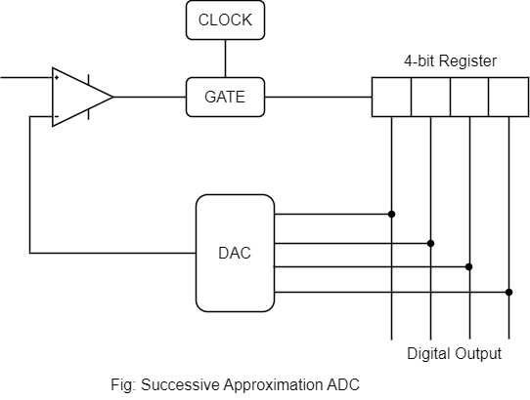
At the starting of the conversion process, the input to the DAC is set with MSB 1 and other 3-bits are set to 0 i.e. 1000, this represents the midpoint of digital range. This gives the analog output voltage from digital to analog converter which is equivalent to half of the full scale analog voltage. This approximation is compared with the input voltage, if it is smaller than the input voltage a second approximation is made and the next bit is turned on. If this result in a voltage which is greater that the input voltage the bit is turned OFF and the next bit is compared.
Since, each of the bits is tried or compared in sequence with n-bit word, it takes n steps to make the comparison. Thus, if the clock has a frequency of time is 1/F then time taken to generate the digital word is n/F.
Advantages:
- High accuracy
- Low power consumption
- Simple Circuit
- Easy to interface
Disadvantages:
- Slow conversion rate
- Limited resolution
- Non-linear behavior
- Susceptibility to noise

4.3.4 Dual Slope ADC
It is popular method of converting an analog to digital. The analog voltage to be converted into a digital signal is applied through an electronic switch to an integrator or ramp generator circuit. The counter operated during both positive and negative slope interval of the integrator gives the digital output.
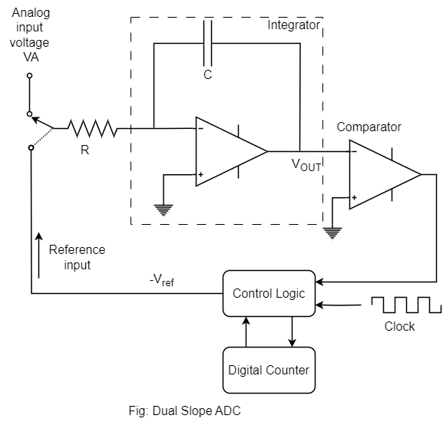
For a fixed time interval, the analog input voltage, connected to the integrator raises the voltage in the comparator to some positive levels. At the end of fixed time intervals the voltage from the integrator is greater for greater input voltages. At the end of the fixed count interval, the count is set to zero and the electronic switch connects the integrator to a reference or fixed input. The integrator output or input to capacitor then decreases at a fixed rate until it drops below the comparator reference voltage, at which the control logic receives a signal to stop the count. The count shown by the counter at this time represents the digital output of the ADC.
Advantages:
- Clock frequency drift is compensated for as the same clock and integrator are used to perform conversion during the positive and negative intervals of the count period.
- The above reasons also increases accuracy
- Low conversion time
- Setting the clock rate and reference input can give desired scaling of the counter output.
Disadvantages:
- Complicated circuitry
- Higher cost

4.3.5 Introduction to Delta-Sigma (ΔΣ) ADC
A Delta-Sigma (ΔΣ) Analog-to-Digital Converter (ADC) is a type of ADC that achieves high-resolution digital conversion by oversampling the input signal and using a delta-sigma modulation technique. It is commonly used in applications where high resolution, low noise, and high dynamic range are required, such as audio processing, instrumentation, and telecommunications.

- Types of DAC
4.4.1 Weighted Resistor DAC
It consists of a precision ladder network, a reference precision voltage supply, logic inputs, semiconductor switches and operational amplifier. The input A, B, C, D….H are binary inputs which are assumed to have values of either or (low) or 8V (high), when the input is high, the switch closes and connects a precision reference supply to the input resistor and when the input is low, the switch is open. The reference supply produces a very stable, precise voltage required for generating an accurate analog input. The operational amplifier is used as summing amplifier, which produces the weight sum of the binary inputs.
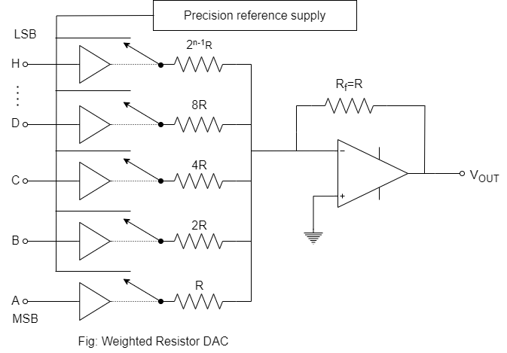
In an 8-bit code input the witch A is actuated by MSB and the switch H is actuated by LSB. The ‘A’ input has R_{in} = R and so the Op-Amp possesses the voltage at ‘A’ with no attenuation i.e. the output voltage V_{OUT} is equal to the reference voltage, V_{ref}. the ‘B’ input has R_{in}=2R. So, it will be attenuated by half. Similarly the input ‘C’, input ‘D’ and input ‘H’ will be attenuated by 1/4, 1/8 and 1/2^{n-1} respectively.
The amplifier output can be expressed as;
$$V_{OUT}=-\left(V_{A}+\frac{1}{2}V_{B}+\frac{1}{4}V_{C}+\frac{1}{8}V_{D}+ ………+\frac{1}{2^{n-1}}V_{H} \right)$$
The $–Ve$ sign represents the amplifier is the inverting amplifier.
Disadvantages:
- The difference between the resistance values corresponding to LSB & MSB will increase as the number of bits present in the digital input increases.
- It is difficult to design more accurate resistors as the number of bits present in the digital input increases.

4.4.2 R-2R Ladder DAC
One of the most widely used DAC circuit is R-2R ladder network (Binary Ladder) where the resistors used have only two values and that in the ratio of only 2 and 1. The output current I_{OUT} depends on the positions of the four switches and the digital inputs D₀, D₁, D₂ and D₃ control the state of the switches. The current is allowed to flow through an Op-Amp current is allowed to flow through an Op-Amp current to voltage converter to give V_{OUT}.
$$V_{OUT}=\left(\frac{D_{0}2^{0}+D_{1}2^{1}+D_{2}2^{2}+D_{3}2^{3}}{2^{4}}\right)×V_{ref}$$
In general,
$$V_{OUT}=\left(\frac{D_{0}2^{0}+D_{1}2^{1}+D_{2}2^{2}+D_{3}2^{3}+ ……+D_{n-1}2^{n-1}}{2^{4}}\right)×V_{ref}$$

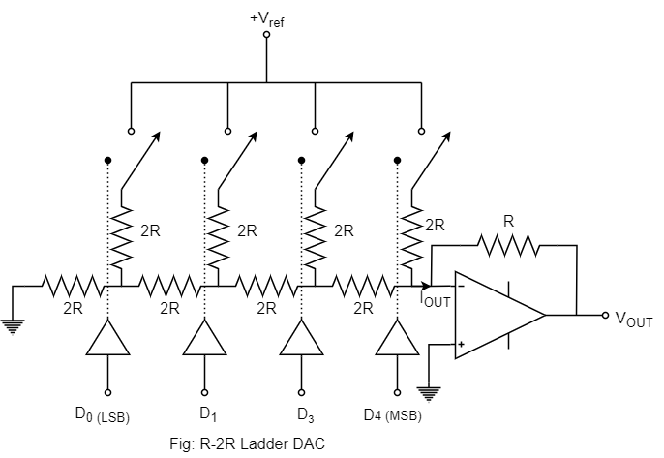
Thus, we can have more digital or binary inputs and greater quantization for each step by using more sections of ladder network. In general, the voltage resolution for an n-stage ladder network is given as $\frac{V_{ref}}{2^{n}}$.

4.4.3 PWM type DAC
A Pulse Width Modulation (PWM) Digital-to-Analog Converter (DAC) is a type of DAC that converts digital signals into analog voltages by varying the duty cycle of a pulse train. PWM DACs are commonly used in applications where precise control of analog voltages is required, such as motor control, power supplies, audio amplifiers, and LED dimming.
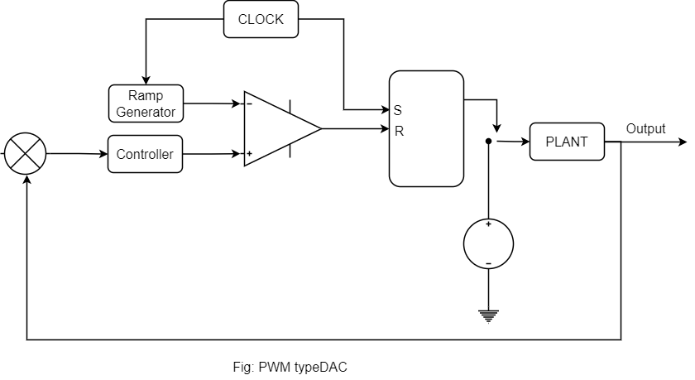

- Probes and Connectors
Probes and connectors are essential components used in electronic measurement and testing applications to establish electrical connections, interface with circuits, and acquire data accurately.
4.5.1 Test Leads: Twisted pair unshielded test leads

4.5.2 Shielded Cables
A wire wrapped with a conductor outside the conductor is called a shielded cable. The wrapped conductor is called a shielding layer, which is usually a braided copper mesh or copper foil (aluminum). The shielding layer needs to be grounded, and external interference signals can be guided into the earth by this layer.
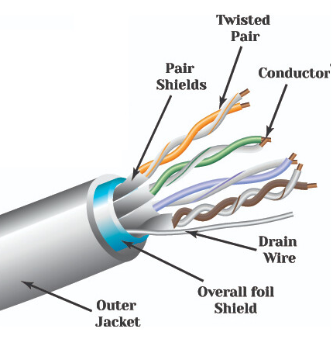
Construction:
- Conductors: Shielded cables typically consist of one or more insulated conductors, usually made of copper or aluminum. These conductors carry electrical signals or power from one point to another within the cable.
- Insulation: Each conductor is individually insulated with a dielectric material, such as PVC (Polyvinyl Chloride), PE (Polyethylene), or FEP (Fluorinated Ethylene Propylene). The insulation prevents electrical contact between the conductors and provides electrical safety.
- Shielding: The conductors are surrounded by a metallic shielding layer, such as aluminum foil or braided copper mesh. The shielding layer is grounded to dissipate and divert external electromagnetic and radio frequency interference, preventing it from affecting the signals carried by the conductors.
- Outer Jacket: The entire cable assembly is covered by an outer jacket made of PVC, PE, or other materials. The outer jacket provides mechanical protection, insulation, and environmental resistance to the cable assembly.
4.5.3 Connectors
A connector is a coupling device that joins electrical terminations to create an electrical circuit. Connectors enable contact between wires, cables, printed circuit boards, and electronic components.
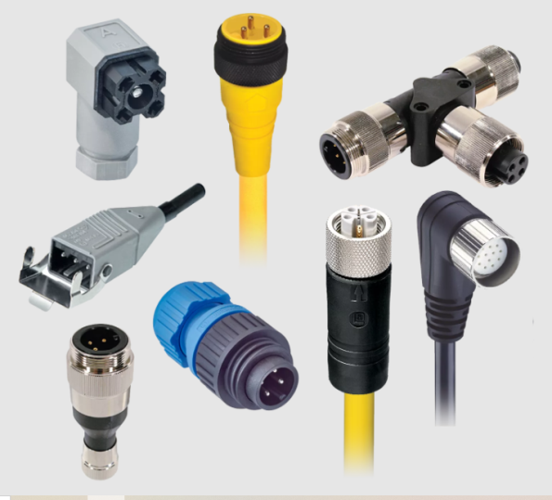

4.5.4 Low Capacitive Probes
A Probe with very low input capacitance usually used in handling with high frequency signals as it doesn't present significant capacitive loading. Low capacitive probes are designed to measure capacitance with high precision and accuracy, particularly in circuits where the capacitance values are relatively small. They typically have a low input capacitance themselves to minimize loading effects on the circuit under test.
Low capacitive probes often feature specialized designs and construction techniques to minimize stray capacitance and maximize sensitivity. They may include precision components, shielding, and compensation circuits to ensure accurate measurements.
4.5.5 High Voltage Probes
High capacitive probes are designed to measure capacitance in circuits or components with larger capacitance values. They are optimized for higher capacitance ranges and may have higher input capacitance themselves compared to low capacitive probes.
High capacitive probes may feature robust construction and components capable of handling higher capacitance values without saturation or distortion. They may also include built-in compensation circuits or filtering to improve measurement accuracy and stability.

4.5.6 Current Probes
Current probes are designed to measure current flowing through a conductor without the need for direct electrical contact. They can be non-invasive (clamping around the conductor) or invasive (inserting into the circuit). Current probes are designed to offer a convenient way of measuring current. They can be AC coupled, using current transformer technology or AC/DC coupled. In either case they include a split-core geometry that makes it easy to enclose the current carrying conductor without having to unsolder it. The Teledyne LeCroy CP030 is a good example of an AC/DC current probe capable of measuring up to 30 amps with a bandwidth of 50 MHz
